ZTC5273a-b_SMA_baby club triggered emails for FOM and GUM

**ZTC5273a SMA_baby club triggered email for FOM**

Subject line: Moving to the next stage: discover our follow-on milks

Preheader: With vitamin D which helps support the normal function of baby’s immune system



**Discover our**

**follow-on milks**



Image links to https://www.smababy.co.uk/formula-milk/follow-on-milk/

Hi [FIRSTNAME],

Time flies! Your little one is already 6 months. At this age your baby's development progresses quickly and their need for iron increases.

We have developed a range of **follow-on milks**, from 6 months+, to support babies’ **unique nutritional needs**.

Our follow-on milks are enriched with **iron** which helps support normal **cognitive development in baby’s brain**.

These also contain **vitamin D** which helps support the normal function of **baby’s immune system**.

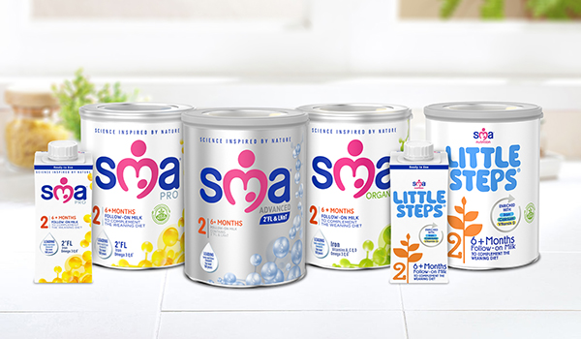

Find out more

Find out more button links to <https://www.smababy.co.uk/formula-milk/follow-on-milk/>

Where to buy

Where to buy button links to <https://campaigns.adimo.co/campaigns/sma/sma-all-follow-on-milks-landing-page-design/?touchpointIdentifier=f960e7e3-b6be-4d87-a63e-86ccbe89f6b3>

**Recyclable Lid & Scoop**

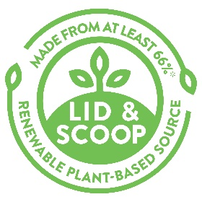

The **recyclable lid & scoop** in our powder products now contain at least 66%* **plant-based renewable resource.** At least 66% of the lid and 90% of the scoop are plant-based plastic. It is still a plastic, but made from sugar cane. It is not bio-degradable or compostable.

It is still **widely recyclable**, within UK & Ireland, but check your local recycling facility.

*66% of the plastic in the lid & scoop is now produced from sugar cane, a plant-based renewable resource.

Find out more

Find out more button links to https://www.smababy.co.uk/formula-milk/follow-on-milk/

**SCIENCE INSPIRED BY NATURE**



Our expert team at SMA® Nutrition is dedicated to understanding the complex structure of breast milk and to applying the learnings from nature to our own products.

We have been **leading research in baby nutrition for over 100 years** and have produced a range of follow-on milks, from 6 months+, expertly developed with nature in mind to help support babies’ unique nutritional needs

Find out more

Find out more button links to https://www.smababy.co.uk/formula-milk/follow-on-milk/





**Important notice**

Breast milk is best for babies and breastfeeding should continue for as long as possible. **SMA® ADVANCED Follow-on Milk, SMA® PRO Follow-on Milk, SMA® ORGANIC Follow-on Milk and LITTLE STEPS® Follow-on Milk** are only suitable for babies over 6 months as part of a mixed diet. They should not be used as a substitute for breast milk during the first 6 months. The decision to start weaning or to use these products before 6 months, should be made only on the advice of a doctor, midwife, health visitor, public health nurse, dietitian or pharmacist, based on baby’s individual needs.

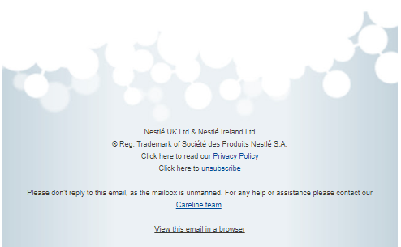

ZTC5273a/01/2021

**ZTC5273b SMA_baby club triggered email for GUM**

Subject line: Discover our growing up milks tailored for children’s unique nutritional needs

Preheader: With vitamins A, C & D which help support the normal function of a child’s immune system.



**Discover our**

**growing up milks**



Image links to https://www.smababy.co.uk/formula-milk/growing-up-milk/

Hi [FIRSTNAME],

Your baby’s first birthday is coming up in a few weeks, marking the start of big developments and lots of exciting firsts! As your little one goes through this incredible period of growth and development, their nutritional needs will also evolve.

To support these **unique nutritional needs**, our experts have developed a range of **growing up milks**, suitable for young children from 1 to 3 years old.

Our growing up milks are enriched with **vitamin D** and **calcium** which support the normal **growth and development of bones.**

These also contain **vitamins A, C & D** whichhelpsupport the normal function of a **child’s immune system.**

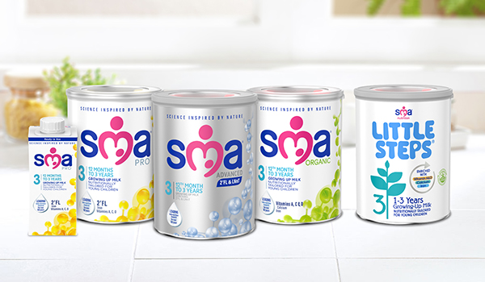

Find out more

Find out more button links to https://www.smababy.co.uk/formula-milk/growing-up-milk/

Where to buy

Where to buy button links to <https://campaigns.adimo.co/campaigns/sma/sma-all-growing-up-milks-landing-page-design/?touchpointIdentifier=5fc395b5-9271-4838-9299-8cd1f76b62e5>

**Recyclable Lid & Scoop**



The **recyclable lids & scoops** in our powder products now contain at least 66%* **plant-based renewable resource**. At least 66% of the lid and 90% of the scoop are plant-based plastic. It is still a plastic, but made from sugar cane. It is not bio-degradable or compostable.

It is still **widely recyclable**, within UK & Ireland, but check your local recycling facility.

*66% of the plastic in the lid & scoop is now produced from sugar cane, a plant-based renewable resource.

Find out more

Find out more button links to https://www.smababy.co.uk/formula-milk/growing-up-milk/

**SCIENCE INSPIRED BY NATURE**



SMA® Nutrition has been **leading research in baby nutrition for over 100 years** and our team of nutritionists have expert understanding of the evolving nutritional needs of young children, as they go through an amazing period of physical growth and cognitive development.

Find out more

Find out more button links to https://www.smababy.co.uk/formula-milk/growing-up-milk/





**Important notice**

Breast milk is best for babies and breastfeeding should continue for as long as possible. **SMA® ADVANCED Growing Up Milk and SMA® ORGANIC Growing Up Milk** are suitable for young children from the 12th month, as part of a healthy balanced diet and are not suitable as a breast milk substitute. The decision to start weaning or to use follow-on milk before 6 months, should be made only on the advice of a doctor, midwife, health visitor, public health nurse, dietitian or pharmacist, based on baby’s individual needs. **SMA® PRO Growing Up Milk and LITTLE STEPS® Growing Up Milk** are suitable for young children from 1-3 years, as part of a healthy balanced diet and they are not a breast milk substitute. 

ZTC5273b/01/2021